Stuff can buy -

ACR122U USB NFC Reader ChipSilicon Contactless Smart Card Reader
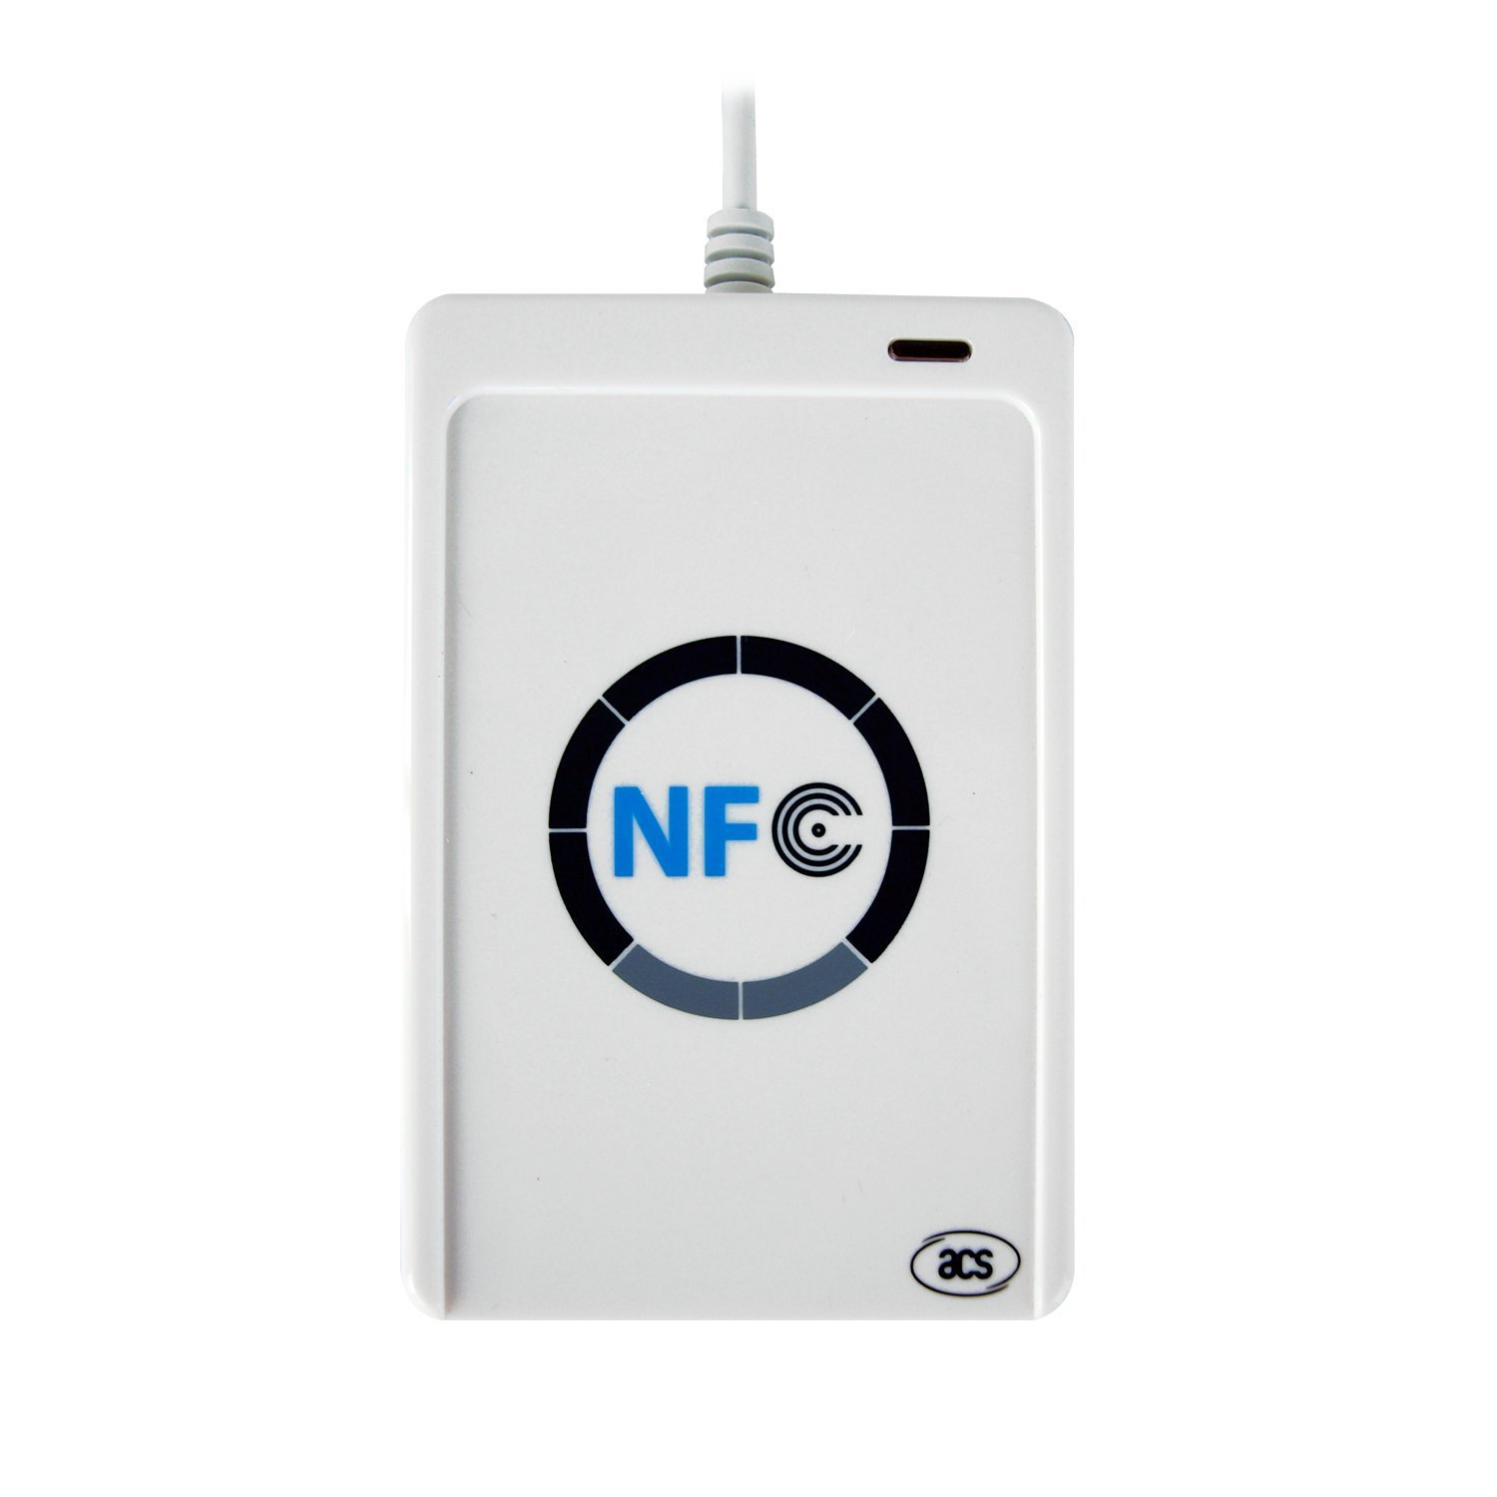
Source : Amazon.in
Price : 2,850.00 Rs

Dont Support NTAG Standard Cards

Support ISO 14443 Type A and B cards - MIFARE cards (Classics, DES Fire)
- NFC tags access speed = 424kbps
- Supports Android: OS 3.1 and above

ACR1252U NFC Forum Certified NFC Reader

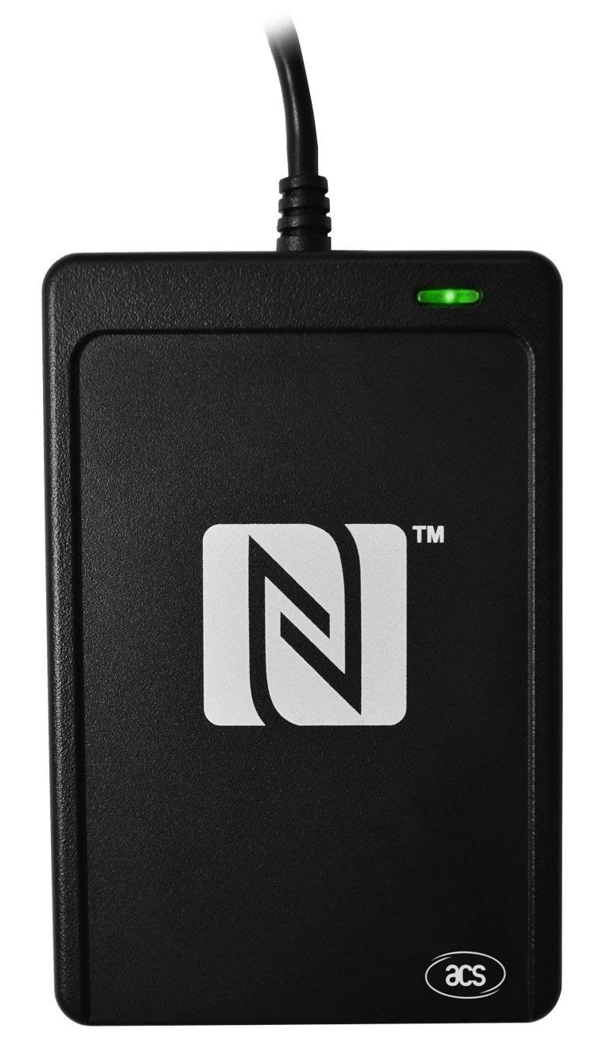

Source : Amazon.in (Rs 4,703),
AliExpress (Price : US $156.08 ==>Rs 10,965)

Supports ISO 14443 Type A and B cards, MIFARE, FeliCa, and all 4 types of NFC (ISO/IEC 18092) tags
- Supports MIFARE 7-byte UID, MIFARE Plus and MIFARE DESfire
- Built-in anti-collision feature (only 1 tag is accessed at any time)
- NFC Support: NFC Reader/Writer Mode, Peer-to-Peer Mode, Card Emulation Mode

ACR1255 13.56mhz RFID Card Reader Writer
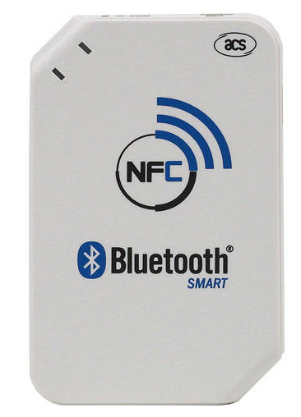

Source : Banggoods.com (Price : Rs 4472)

Support contactless smart card:
ISO14443 Parts 1-4, ISO18092 (NFCIP-1) Compliant, FeliCa Card, NFC Tag Types 1,2,3,4.
Support 2 LEDS for smart card and wireless transmission.
Support Bluetooth 4.0 protocol for data transmission(single-mode operation).
Support User-controllable Buzzer.
Switch for Bluetooth/OFF/PC-linked modes.
USB 2.0 full speed (12 Mbps).
Li-ion rechargeable battery ( for portable usage).
Mini USB port.
CCID protocol.
PC/SC compliant.
OS Platform support:
WHQL from Windows 2000, XP and up.
Linux .
¡ Android 3.1 and above .
Compliance to Standards and Certifications:CE,FCC,VCCI,RoHS,BQB.
Compliance to CSCR API Standardization .

Proxmark 3 EVO

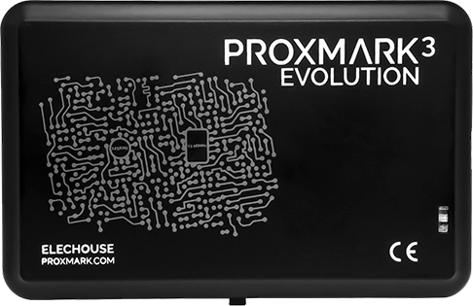
Source : sells from official sellers
Price : 18,000 – 23,000,
Amazon.com (Price : 18,000)

